**Master of None** 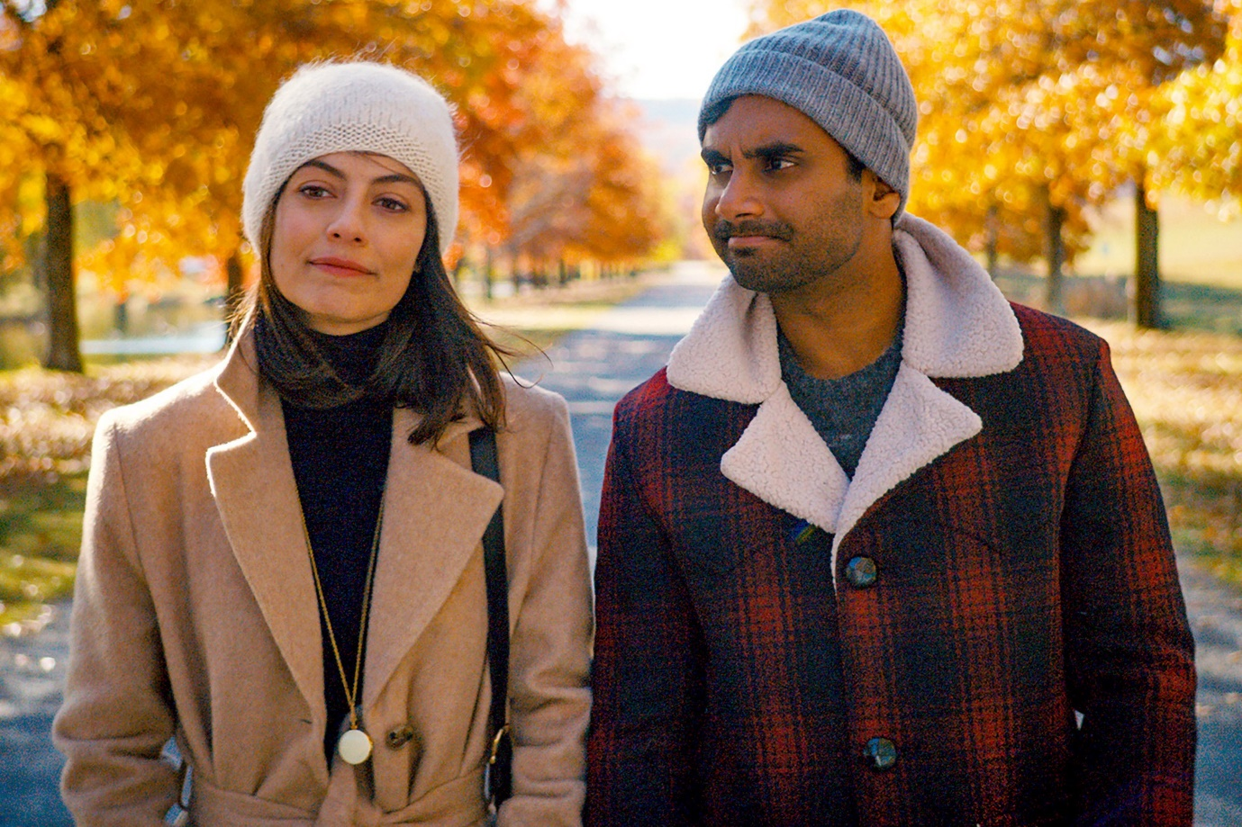

**Master of None**, an American comedy drama television *series* which was created by Aziz Ansari and Alan Yang starring Ansari as the protagonist of the series *Dev Shah*. It was first broadcasted on November 6, 2015 on Netflix. It’s second season was streamed on May 12, 2017.

**Master of None: Cast**

Following are some of the prominent actors and characters of the series:

Aziz Ansari being **Dev Shah**

Noel Wells being **Rachel Silva**

Eric Wareheim being Arnold Baumheiser

Kelvin Yu being Brian Chang

Lena Waithe being Denise

Alessandra Mastronardi being Francesca

Todd Barry being Todd

H. Jon Benjamin being Benjamin

Leonard Ouzts being Lawrence

Shoukath being Dev’s father

Fatima being Dev’s mother 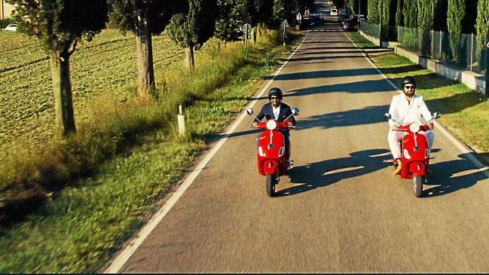

**Master of None: Plot**

**Dev Shah**, a 30-year-old actor, following his personal, romantic, and professional experiences. In the *first season* *Dev* is seen enjoying his life with his love interest *Rachel*, and trying to think what does he wants to do with his life. Few questions pop up in his mind like what if he gets married? Will he ever be able to live happily with *Rachel* without any conflict? In the last of the *season* *Rachel* moves to Tokyo with her friend to enjoy the rest of her young adult life and *Dev* is seen making his mind to move to Italy in order to study *pasta*-making at culinary school. Since at one point of time in season 1, he found out that he makes good *pasta* with the pasta maker which *Rachel* has bought for him.

*Second season* focused mostly on the love life of *Dev* and his friends. After dating so many women, finally he’s seen with **Francesca** at the end of the *season*.

So, if there’ll be any *season 3* of *Master of None*, then *Dev* is likely to be seen as a married man, husband of *Francesca* and both of them enjoying their life.

**Master of None: Season 3**

When *Dev* was asked about whether there’ll be another *season* of *Master of None*, then he says he’s willing to do another but for that he needs some time to prepare himself for bringing the changes in his role from a young adult person to a responsible married man. Thus, it’s concluded that the creator wants another *season* but not at this time.

Till that time, you can enjoy the *trailer* of *Season 2* of *master of None*😊

https://www.youtube.com/watch?v=v10fhaMUhnI